**Project Topic: Wifi Deauthentication Attack**

**Group Members:**

**1. Aansh Chandrakant Dubey (B22AI058)**

**2. Swaksh Patwari (B22AI065)**

**Session: Spring 2024**

**Instructor: Professor Sumit Kalra**

**Task 1: Deauthentication attack and WPA2 password hack**

**Problem Statement:**

**Disrupt the connection between a target device (with a given MAC or IP address) and a router without physical access to either device. This attack aims to force the target device to disconnect from the network temporarily**

**Requirements:**

**2 clients, one to launch an attack and to be the victim.**

**Attacker:**

1. **Must have a wireless adapter**

**Procedure:**

1. **Identify the Wireless Card:**

* **Open a terminal and run the command iwconfig to see the list of network interfaces.**
* **Note the name of your wireless card (here wlo1).**

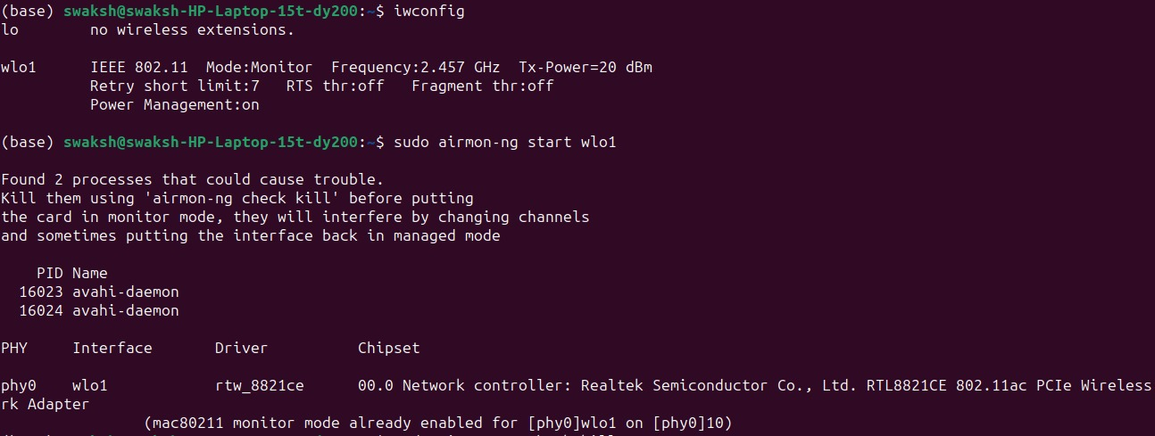

1. **Put Your Wireless Card into Monitor Mode:**

* **Run the command airmon-ng start wlo1. This command puts your wireless card into monitor mode, allowing it to monitor all traffic on the network.**
* **Some processes running on the network could interfere with the listening of the wireless card, hence kill those processes using the sudo airmon-ng check kill**

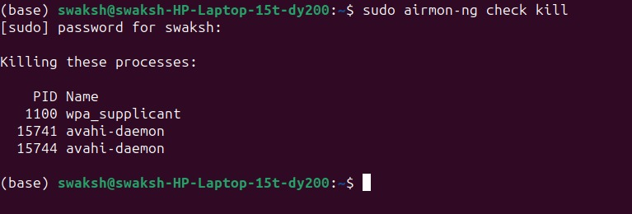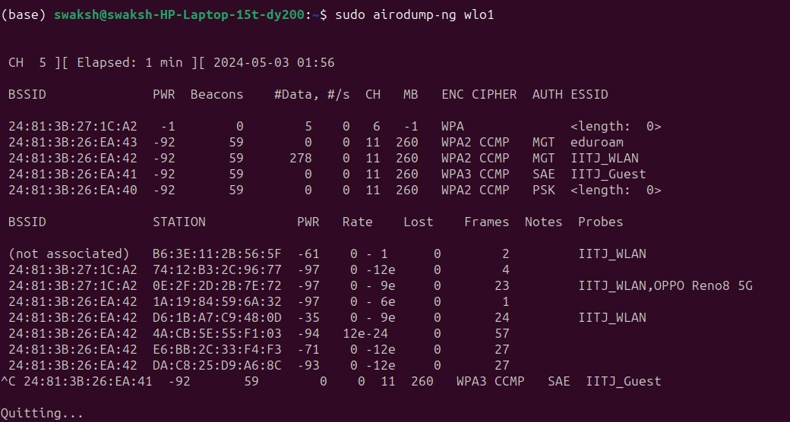

1. **Identify Target Router and Device:**

* **Identify the BSSID (MAC address) and channel of the router to which the target device is connected.**
* **Run the command airodump-ng wlo1 --bssid [router's BSSID] --channel [router's channel] to capture information about devices connected to the router.**
* **Note the MAC address of the target device.**

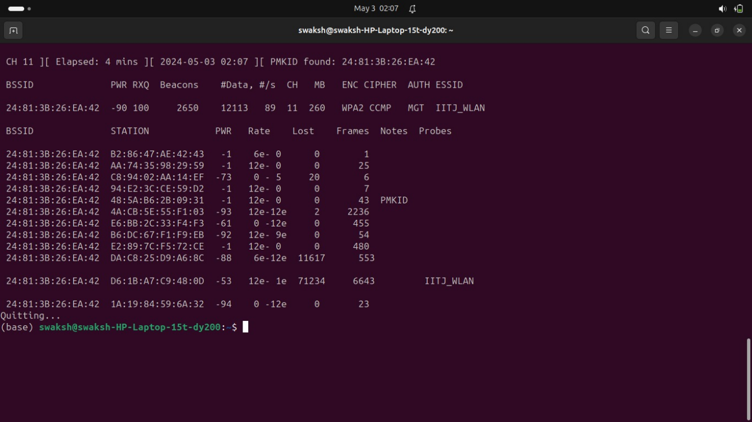

**sudo airodump-ng wlo1 -d <bssid>**

1. **Deauthenticate Clients:**

* **Use the sudo aireplay-ng 0 -a [BSSID] wlo1 command to deauthenticate clients from the target network. This step forces clients to reconnect and triggers the capture of the handshake**

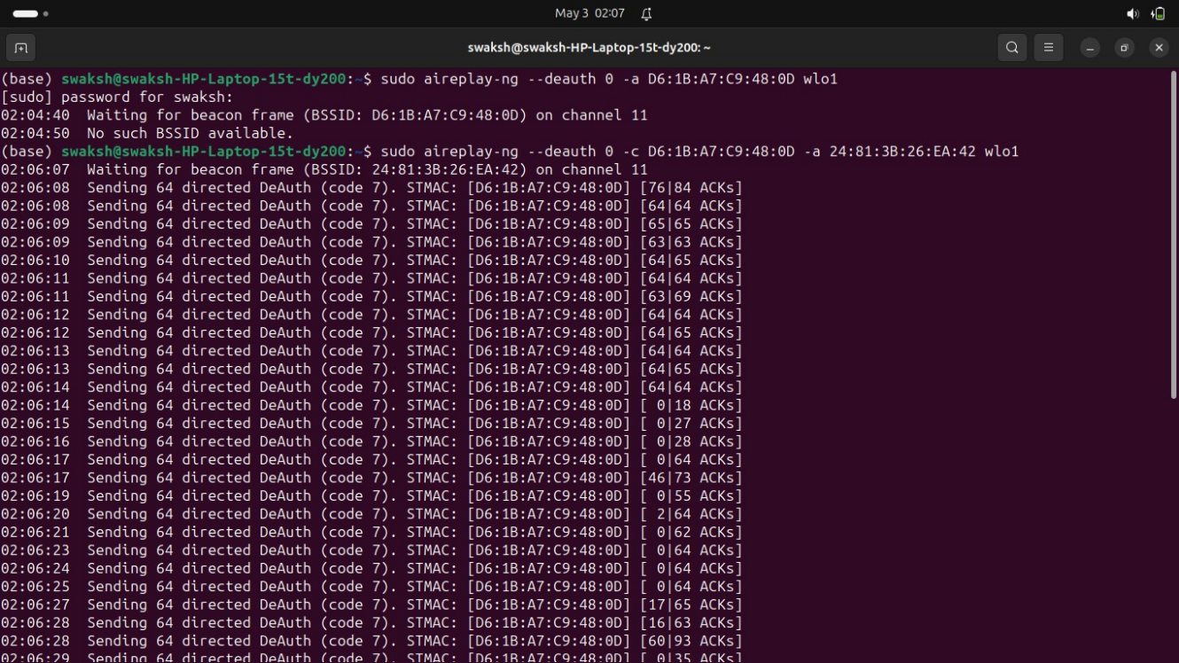

1. **Capture Handshake:**

* **Use the sudo airodump-ng -w hack1 --bssid [BSSID] -c [channel] wlan0mon command to capture the four-way handshake from the target network.**

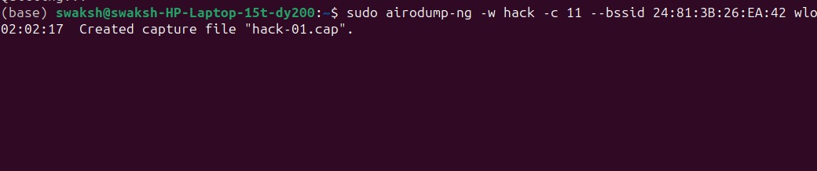

1. **View Captured Handshake:**

* **Open the captured file (hack1-01.cap in this case) in Wireshark to view the captured handshake.**
* **Filter by eapol packets.**
* **Extensible Authentication Protocol (EAP) over LAN (EAPoL Protocol) is a network port authentication protocol used in IEEE 802.1X (Port Based Network Access Control) developed to give a generic network sign-on to access network resources.**

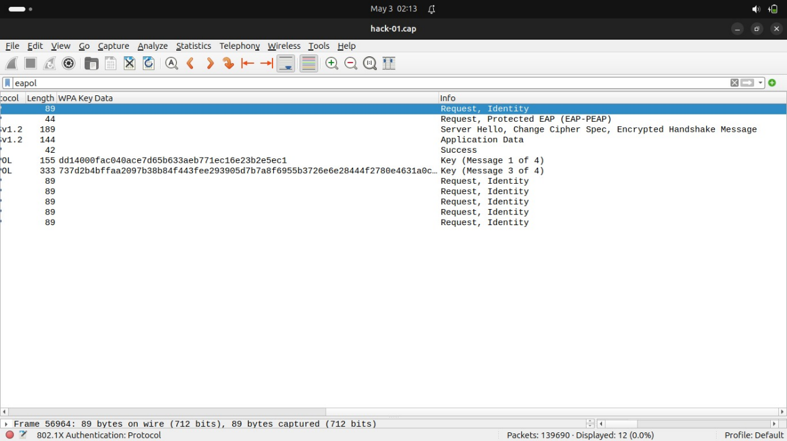

**Observations:**

1. **Not all users were found by aircrack-ng**

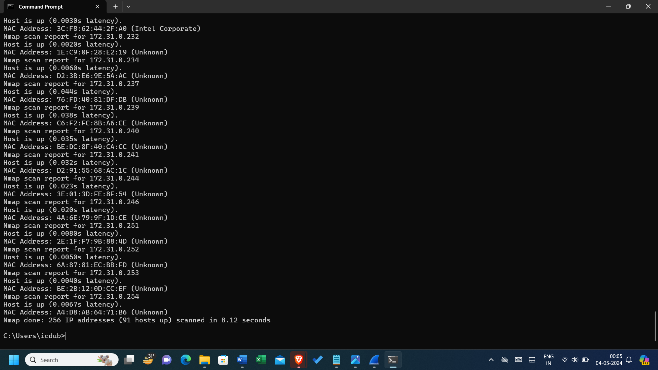

**As shown by nmap, 91 hosts are up in the network but only about 5 are captured by aircrack.**

1. **Once disconnected the user does not show up on aircrack-ng**
2. **The identity of the attacker can be detected by the victim using wireshark or any other packet capturing tool, by matching MAC address to the IP address by using network ARP packets.**

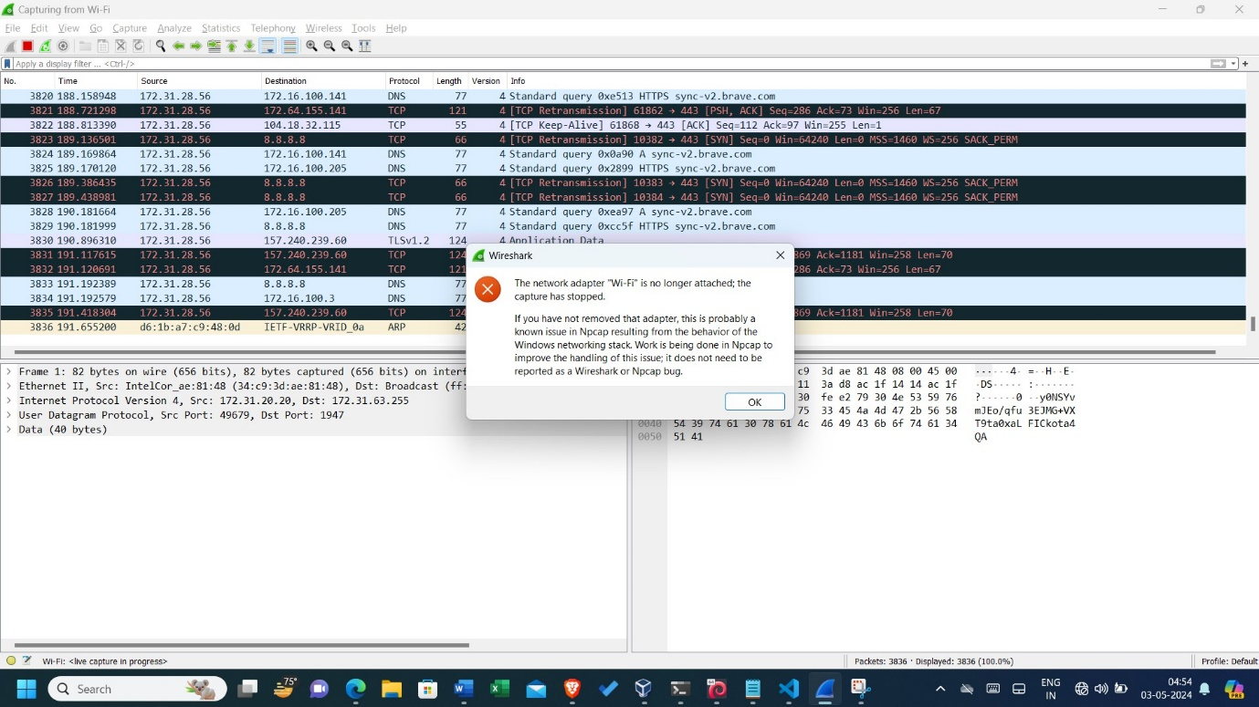

**Task 2: Increase the number of potential victims for the attack**

**Problem Statement:**

**To find all the users connected to a particular router of IITJ_WLAN network.**

**Requirements:**

**2 clients, one to launch an attack and to be the victim.**

**Attacker:**

1. **Must have a wireless adapter.**

**Procedure:**

**To show all the users on the network, we will try to**

**1. Get closer to the router**

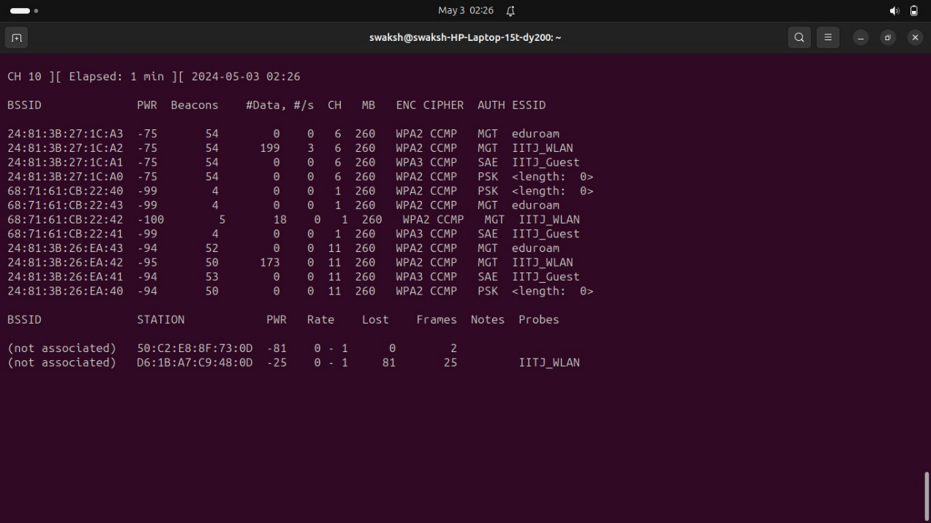

**Observations:**

* **The number of routers in range increased but the number of potential victims are the same.**

1. **Change the band using –band**

**802.11a: Also introduced in 1999, 802.11a operates in the 5 GHz frequency band and supports data rates up to 54 Mbps. It offers faster speeds and less interference compared to 802.11b.**



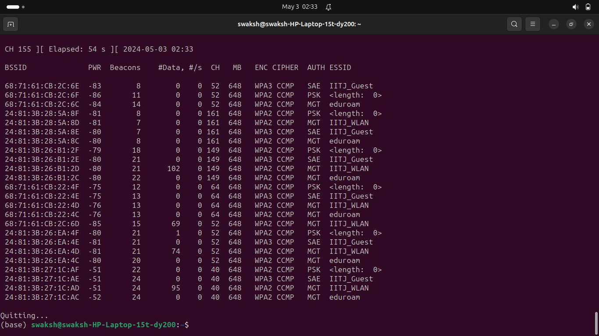

**802.11g: Introduced in 2003, 802.11g operates in the 2.4 GHz frequency band and supports data rates up to 54 Mbps. It is backward compatible with 802.11b and offers improved performance.**



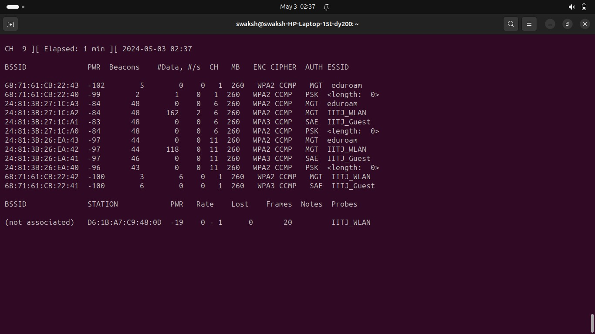

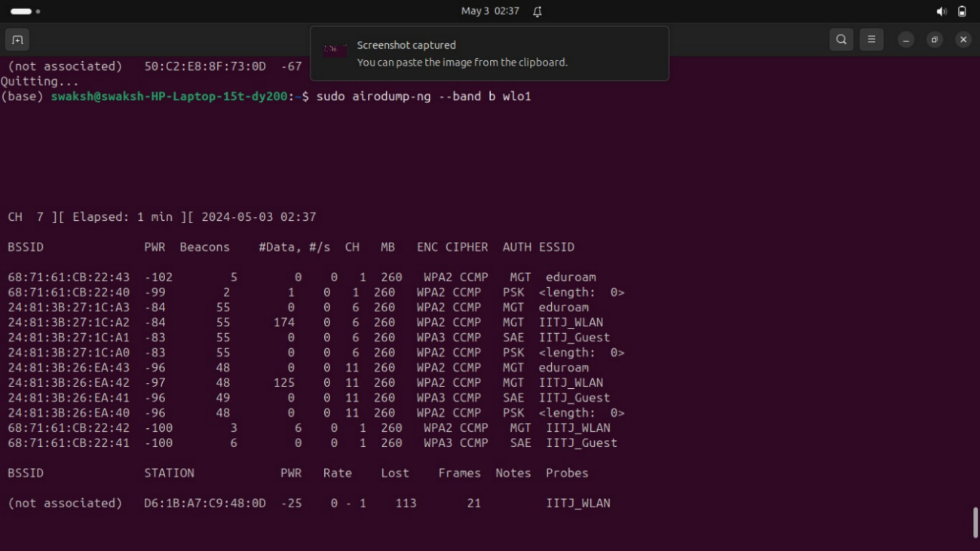**802.11b: Introduced in 1999, 802.11b was one of the earliest Wi-Fi standards. It operates in the 2.4 GHz frequency band and supports data rates up to 11 Mbps.**

1. **Check for hardware limitations:**

**The Realtek RTL8821C wireless network adapter, which supports the 802.11ac standard, is capable of supporting multiple Wi-Fi modes in addition to 802.11ac. These modes include:**

* **802.11a: This mode operates in the 5 GHz frequency band and supports data rates up to 54 Mbps.**
* **802.11b: This mode operates in the 2.4 GHz frequency band and supports data rates up to 11 Mbps.**
* **802.11g: This mode operates in the 2.4 GHz frequency band and supports data rates up to 54 Mbps.**
* **802.11n: This mode operates in both the 2.4 GHz and 5 GHz frequency bands and supports higher data rates compared to 802.11a/b/g standards, with speeds up to several hundred Mbps.**
* **802.11ac: This mode, operates exclusively in the 5 GHz frequency band and supports higher data rates than previous standards, exceeding 1 Gbps under optimal conditions.**

**Conclusion:**

* **In order to capture more victims, we would need such hardware antenna that could capture packets over long ranges, i.e. the number of victims being captured currently is limited by the range of the Realtek RTL8821C wireless network adapter.**

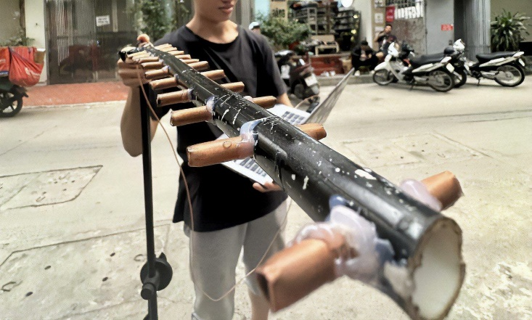

**An antenna that was used to capture personal Wifi’s encryption key using aircrack-ng in Singapore**

**Task 3: A stealthier way to hack WPA2 passwords – PMKID Attack**

**Explaining the attack through terminology:**

1. **PSK (Pre-Shared Key):**
   * **PSK stands for Pre-Shared Key. It's also commonly referred to as the Wi-Fi password or passphrase.**
   * **In a Wi-Fi network secured with WPA2-PSK (Wi-Fi Protected Access 2 - Pre-Shared Key), users must enter this key to authenticate and connect to the network.**
   * **The PSK is a secret key shared between the client devices (like smartphones, laptops) and the access point.**
   * **It's used to derive various cryptographic keys during the connection establishment process, ensuring secure communication between the client and the access point.**
2. **PMK (Pairwise Master Key):**
   * **PMK stands for Pairwise Master Key.**
   * **It's a derived key used in WPA2-PSK networks for secure communication between a client device and an access point.**
   * **The PMK is derived from the PSK along with other parameters exchanged during the initial handshake between the client and the access point.**
   * **Once generated, the PMK is used to create other session keys, such as the Pairwise Transient Key (PTK), which are used for encrypting and decrypting data exchanged between the client and the access point.**
3. **PMKID (Pairwise Master Key Identifier):**
   * **PMKID stands for Pairwise Master Key Identifier.**
   * **It's a unique identifier associated with the PMK.**
   * **In Wi-Fi networks, the PMKID is included in the authentication process between a client device and an access point.**
   * **The PMKID allows devices to quickly authenticate and establish a connection without needing to perform the full authentication process every time they reconnect to the network.**
   * **Attackers can capture PMKID information from Wi-Fi networks and use it to perform offline brute-force attacks to crack the Wi-Fi password. This is because the PMKID allows them to obtain the necessary information to attempt to derive the PMK and, subsequently, the Wi-Fi password without needing to actively interact with the network during the attack.**

**Why would even a router give away the PMKID to an unauthorized stranger?**

* **The strength of the PMKID, and the PMK, depends on the strength of the Passphrase. Therefore it's counted to be as safe as the network itself.**
* **Knowing the PMKID definitely increases an attacker’s advantage, on certain networks. The attacker can get what they need *quicker and stealthier*, but it doesn’t change the speed of the actual password cracking process. The attacker will still need to use conventional cracking tools, which will basically try a huge list of passwords against the captured data.**
* **The appropriate defense is a lengthy and complex WPA2 password that would take decades to crack. Or just to upgrade to the new WPA3 encryption standard, if possible.**

**Execution:**

**Requirements: To execute this demonstration, several prerequisites must be met:**

* **A machine running Kali Linux, a specialized operating system for penetration testing.**
* **An Alpha Wi-Fi adapter or an equivalent device capable of monitor mode.**
* **A Wi-Fi access point broadcasting WPA2 and PMK IDs, which are essential for the attack to succeed.**
* **Wi-Fi drivers for the Alpha adapter to ensure seamless connectivity, otherwise use the wireless adapter of the PC itself.**
* **Key dependencies for the hcx tools, including libssl-dev, pkg-config, and libcurl4-openssl-dev.**
* **Cloning and installing the hcx tools and hcx dump tool from their respective GitHub repositories to facilitate the attack.**

**Checking Setup: Verification of the setup involves ensuring that the Wi-Fi adapter is correctly recognized by the system. This can be confirmed using the ifconfig command to list available network interfaces.**

**Attack Steps:**

1. **Step 1: Setting the Adapter to Monitor Mode:**
   * **Utilize airmon-ng to initiate monitor mode on the designated Wi-Fi adapter, enabling passive monitoring of network traffic.**
2. **Step 2: Capturing:**
   * **Employ hcxpcaptool to capture Wi-Fi signals and store them in a file, preserving essential metadata for subsequent analysis.**

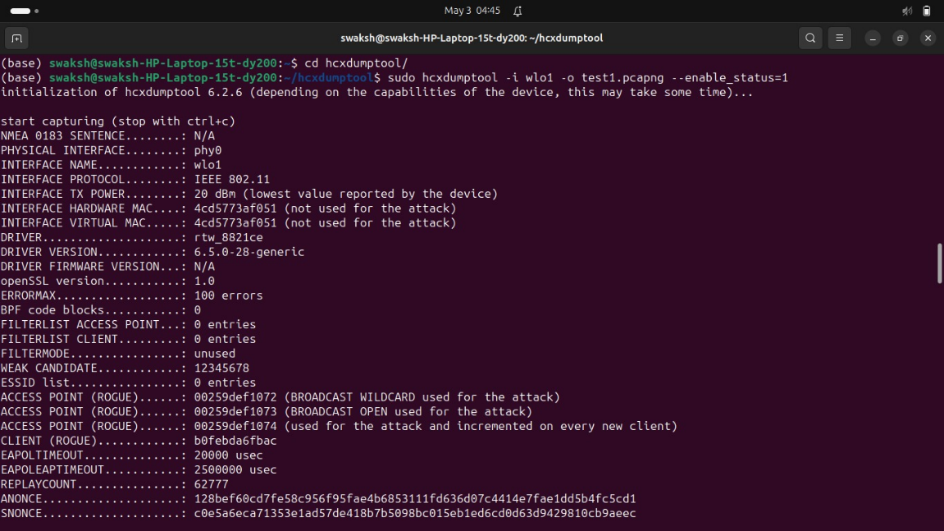

1. **Step 3: Converting and Cracking:**
   * **Convert the captured data file into a text format suitable for analysis, extracting relevant information for further processing.**
   * **Employ hashcat, a powerful password-cracking tool, to decipher password hashes using a predefined wordlist or custom attack strategies.**

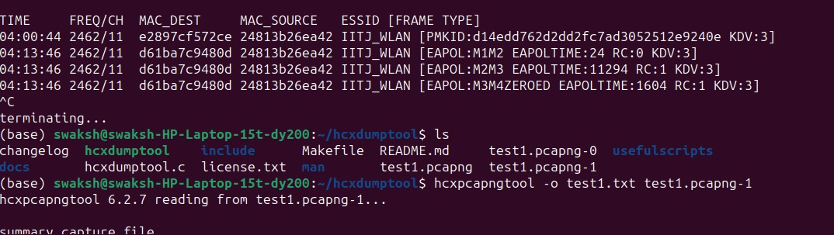

**Mitigation: To mitigate the risks associated with this attack, it's essential to implement robust security measures:**

* **Advocate for the use of complex and unpredictable passwords to resist brute-force attacks.**
* **Consider disabling the broadcast of PMK IDs on compatible routers, thereby reducing the attack surface and enhancing network security.**

# **Task-4: Creating an Evil Twin or Fake Access Point Using Aircrack-ng and Dnsmas**

For this we have proceded in the following way:

**1. Installed dnsmasq:** Encountering an issue related to dnsmasq not being installed, we attempted its installation via `sudo apt install dnsmasq`.

**2.Created a directory for the evil twin setup:** A directory named "eviltwin" was created on our desktop using `mkdir eviltwin`.

In this part of the task, we navigated to the "eviltwin" directory located on the desktop and edited the `dnsmasq.conf` file using the `nano` text editor. Here's an explanation of the content we modified or added in the `dnsmasq.conf` file:

- `interface=at0`: This line specifies the interface on which dnsmasq will operate. In this case, it's set to `at0`, which is commonly associated with virtual interfaces used for wireless attacks like evil twin setups.

- `dhcp-range=10.0.0.20,10.0.0.250,255.255.255.0,12h`: This line defines the DHCP address range to be assigned by the DHCP server. The range specified is from `10.0.0.20` to `10.0.0.250`, with a subnet mask of `255.255.255.0`, and a lease time of `12 hours`.

- `dhcp-option=3,10.0.0.1`: This line sets the default gateway IP address for DHCP clients to `10.0.0.1`.

- `dhcp-option=6,10.0.0.1`: This line specifies the DNS server to be used by DHCP clients, which is also set to `10.0.0.1`.

- `server=8.8.8.8`: This line configures dnsmasq to use Google's public DNS server (`8.8.8.8`) for DNS resolution.

- `server=8.8.4.4`: Another line configuring dnsmasq to use Google's public DNS server (`8.8.4.4`) as an additional DNS resolver.

- `server=64.6.64.6`: This line adds a DNS server provided by Verisign (`64.6.64.6`) for redundancy in DNS resolution.

- `server=64.6.65.6`: Similar to the previous line, this one also adds a Verisign DNS server (`64.6.65.6`) for additional redundancy

- `log-queries`: This line instructs dnsmasq to log DNS queries made by clients.

- `log-dhcp`: Similarly, this line enables logging of DHCP-related activities.

- `listen-address=127.0.0.1`: This line specifies the IP address on which dnsmasq will listen for DNS queries. Here, it's set to `127.0.0.1`, meaning it will only listen for queries originating from the local machine.

- `port=5353`: Finally, this line specifies the port on which dnsmasq will listen for DNS queries. It's set to `5353`, which is commonly used for DNS-over-TLS (DoT) or as an alternate DNS port.

These configurations collectively set up dnsmasq to provide DHCP and DNS services to clients connected to the "evil twin" wireless network.

**3.Activated monitor mode:** We enabled monitor mode on our wireless interface through `sudo airmon-ng start wlo1`. This command seamlessly switched the interface to monitor mode while specifying the channel.

**4.Killed interfering processes:** Before transitioning our wireless interface into monitor mode, we took care of interfering processes by executing `sudo airmon-ng check kill`. This command terminated processes like avahi-daemon, Network Manager, and wpa_supplicant which could potentially disrupt the monitor mode operation.

**5**. **Location** of the wireless network using airodump-ng and then choosing one of them whose evil twin we need to make.

**6. Created the evil twin** using airebase-ng **-e IITJ_WLAN** -c 11 wlo1 command and left the terminal open.

7. Then We have **configured interfaces at0**

* ifconfig at0 up brings up the at0 interface. You can verify it’s now up using the ifconfig command.
* ifconfig at0 10.0.0.1 netmask 255.255.255.0 sets the at0 interface IP address as 10.0.0.1 and the subnet mask as /24.
* route add -net 10.0.0.0 netmask 255.255.255.0 gw 10.0.0.1 creates a static route in our routing table so that any traffic from out clients will be forwarded to the real gateway at 10.0.0.1, which is a part of the 10.0.0.0/24 network.
* iptables -P FORWARD ACCEPT creates a policy to accept forwarding in the chain target. This makes our Linux machine act like a router (even though it isn’t).
* iptables -t nat -A POSTROUTING -o wlan0mon -j MASQUERADE allows us to route outbound traffic without disrupting the normal flow of traffic on the network. The masquerade option kind of acts like Source NAT. See here for more information.
* echo 1 > /proc/sys/net/ipv4/ip_forward enables IP forwarding. The “1” enables IP forwarding while a “0” disables it.

**6. Started dnsmasq:** We initiated dnsmasq with a configuration file using `sudo dnsmasq -C Desktop/eviltwin/dnsmasq.conf -d`. This command launched dnsmasq with the specified configuration file in debug mode.

7. We can also remove Wireless Clients using deauth.

8.Now waiting for the connection

9. Checked network interfaces: Network interfaces were examined using `ifconfig`. This command displayed comprehensive information about the network interfaces, including their IP addresses and configurations.

**Task 5: Deep dive into the library aircrack-ng**

**Aircrack-ng is a powerful suite of tools primarily used for assessing and testing the security of wireless networks. It's commonly employed by security professionals, researchers, and enthusiasts to analyze the security of Wi-Fi networks and to perform various wireless network penetration testing tasks.**

**The suite includes several tools, each serving a specific purpose within the realm of wireless security testing:**

* **airbase-ng: This tool is aimed at attacking clients connected to a wireless network rather than the Access Point (AP) itself.**
  + **It can be used for various attacks targeting client devices.**
* **aircrack-ng: Aircrack-ng is perhaps the most well-known tool in the suite. It's used for cracking the encryption keys of**
* **Wi-Fi networks secured with WEP and WPA/WPA2-PSK protocols. It works by capturing data packets from a target network and using various techniques to recover the encryption key.**
* **airdecap-ng: This tool is used to decrypt captured files containing network traffic encrypted with WEP, WPA, or WPA2 protocols.**
* **airdecloak-ng: It's used to remove WEP Cloaking™ from a packet capture file, allowing further analysis of the captured data.**
* **airdrop-ng: A rule-based tool for wireless deauthentication. It can be used to disconnect clients from a Wi-Fi network by sending deauthentication packets.**
* **aireplay-ng: This tool is used to inject and replay wireless frames, which can be used in various attacks, including deauthentication and fake authentication.**
* **airgraph-ng: It's used for graphing wireless networks, allowing users to visualize and analyze network topologies.**
* **airmon-ng: This tool is used to enable and disable monitor mode on wireless interfaces, which is necessary for capturing raw 802.11 frames.**
* **airodump-ng: Airodump-ng is used for capturing raw 802.11 frames, including information about nearby wireless networks, their clients, and various network statistics.**
* **airolib-ng: It's used to precompute WPA/WPA2 passphrases and store them in a database for later use with aircrack-ng.**
* **airserv-ng: This tool allows multiple applications to use a wireless card simultaneously by creating a TCP/IP server for wireless card access.**
* **airtun-ng: Airtun-ng is used to create virtual tunnel interfaces, which can be useful for various network penetration testing tasks.**
* **packetforge-ng: It's used to create various types of encrypted packets that can be used for injection attacks.**
* **The suite also includes some experimental/unstable tools like easside-ng, tkiptun-ng, and wesside-ng, which offer additional functionalities for communicating with encrypted access points and attacking WPA/TKIP networks.**

**Overall, Aircrack-ng provides a comprehensive set of tools for assessing and testing the security of wireless networks, making it a valuable resource for security professionals and enthusiasts alike.**

**Now, let's analyze the output of airodump-ng, and understand what each column means.**



* **CH: Channel number of the detected access point.**
* **BSSID: Basic Service Set Identifier, unique identifier of the access point.**
* **PWR: Signal strength of the access point, measured in decibels (dBm). Negative values indicate weaker signals.**
* **Beacons: Number of beacon frames received from the access point.**
* **#Data: Number of data frames received from the access point.**
* **#/s: Rate of data frames received per second.**
* **MB: Maximum bitrate supported by the access point.**
* **ENC: Encryption protocol used by the access point (WPA, WPA2, WPA3, etc.).**
* **CIPHER: Encryption cipher used (CCMP, TKIP, etc.).**
* **AUTH: Authentication method used (PSK, MGT, SAE, etc.).**
* **ESSID: Extended Service Set Identifier, the name of the wireless network.**

**Following the Access Point information, we have:**

* **BSSID: The MAC address of the access point or router.**
* **STATION: MAC addresses of devices connected to the access point.**
* **PWR: Signal strength of the connected device.**
* **Rate: Data transfer rate.**
* **Lost: Number of packets lost during transmission.**
* **Frames: Number of frames received from the connected device.**
* **Notes: Any additional notes about the connected device.**
* **Probes: Probing requests sent by the connected device to find available networks.**

**The output gives you a snapshot of nearby wireless networks, their signal strengths, encryption methods, and connected devices, which can be useful for analyzing the security and performance of the networks.**

**Now we will look into the various functions we used from the aircrack library.**

**1. airmon-ng:**

**Function: airmon-ng is a command-line tool used for enabling and disabling monitor mode on wireless interfaces.**

**Purpose: Monitor mode allows a wireless card to capture packets without being associated with any particular network. This mode is essential for many wireless security testing and analysis tasks, such as packet sniffing, network monitoring, and penetration testing.**

**Usage:**

**airmon-ng start <interface>: Enables monitor mode on the specified wireless interface.**

**airmon-ng stop <interface>: Disables monitor mode on the specified wireless interface.**

**airmon-ng check: Checks for processes that could interfere with monitor mode and suggests killing them using airmon-ng check kill.**

**2. aireplay-ng:**

**Function: aireplay-ng is a tool used for injecting and replaying wireless frames.**

**Purpose: It's primarily used for testing the security of wireless networks by performing various attacks, including deauthentication attacks, fake authentication, injection of ARP requests, and packet replay attacks.**

**Usage:**

* **aireplay-ng -0 <count> -a <BSSID> -c <client MAC> <interface>: Sends deauthentication packets to disconnect a client from the access point.**
* **aireplay-ng -1 0 -e <ESSID> -a <BSSID> -h <MAC> <interface>: Performs a fake authentication with the access point.**
* **aireplay-ng -3 -b <BSSID> -h <MAC> <interface>: Captures ARP requests to use them in ARP injection attacks.**

**3. airodump-ng:**

**Function: airodump-ng is a packet capture tool used for capturing and analyzing wireless packets.**

**Purpose: It's primarily used for monitoring wireless networks, capturing packets from nearby access points and clients, and analyzing network traffic. It's particularly useful for assessing the security of wireless networks, detecting rogue access points, and troubleshooting network connectivity issues.**

**Usage:**

* **airodump-ng <interface>: Starts capturing wireless packets on the specified interface.**
* **airodump-ng -c <channel> --bssid <BSSID> -w <output file> <interface>: Captures packets from a specific access point and saves them to a file.**
* **airodump-ng --encrypt <encryption type> <interface>: Filters and displays only networks with specific encryption types.**

**These tools, when used together, form a powerful suite for wireless network analysis and security testing. They enable users to perform a wide range of tasks, from monitoring network traffic to actively testing and exploiting vulnerabilities in wireless networks.**